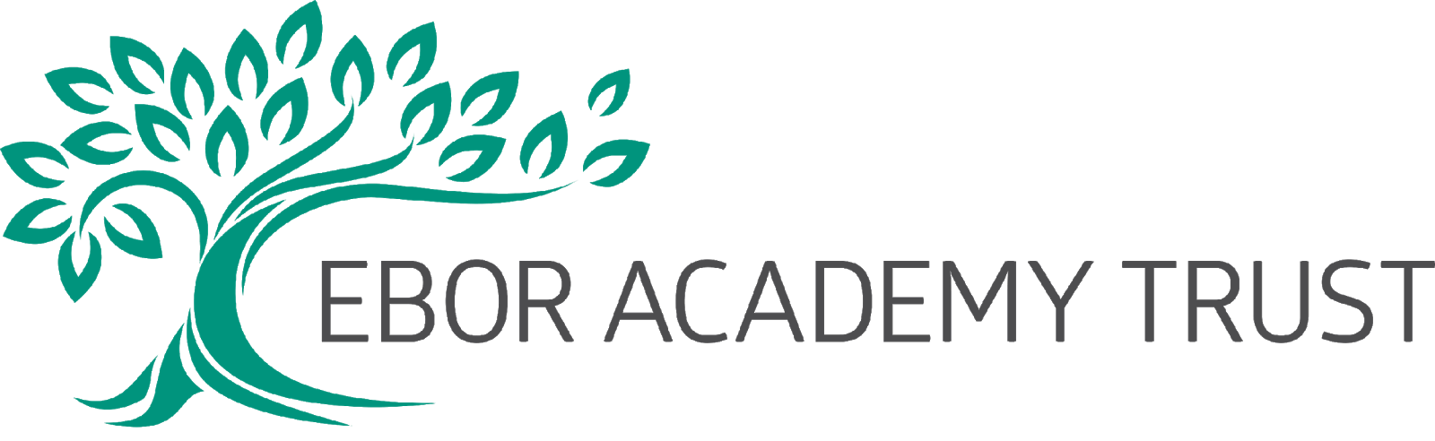

Policy Number

Staynor Hall Primary Academy
Behaviour Policy

Signed: _____________________________

Dated: November 2019

Review Date: November 2022

Review Period: Every three years by LGB

At Staynor Hall Community Primary Academy our philosophy towards responding to behaviour is rooted in the Restorative approach; we aim to provide children with clear boundaries and consequences to behaviours. Our aim is to provide children with the skills and tools to successfully resolve conflict, understanding how the choices they have made have affected others.
We promote positive language and look to find opportunities where children can succeed and have good choices to their behaviour recognised. We use the language of ‘Wow’ and ‘Good’ but equally we are consistent in our high expectations that children with our care guidance and support can make mistakes but then work hard to rectify any damage their actions, words or consequences have caused.
We are passionate in having a whole school approach to behaviour that is consistent. Regardless of being 3 or 11 each child is recognised as an individual, and taught important life skills to be able to fit into the school community and reach their potential. Our behaviour chart is a feature within every classroom, and is referred to throughout the school day. It is the lynchpin to ensuring we have a calm and stable school environment, but it also allows children to take responsibility for their own choices and actions.

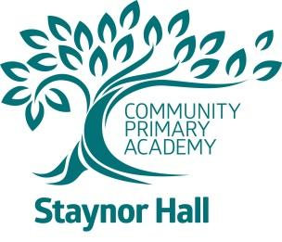
Our Behaviour Expectations
WOW!!
I have made someone in school proud of me.
I am always trying my best.
I am always being supportive.
I challenge myself.
I am always enthusiastic and positive.
I set a good example to others.
I always make the right choice.
WOBBLY BEHAVIOUR

I have disrupted my learning and that of other children in my class.
I am not working as hard as I can.
I am not considering other people’s feelings.
I am not showing respect.
UNACCEPTABLE
My behaviour is persistently disrupting my learning and that of others.
I am making the wrong choices, even when having chances to make the right choices.
I am using violence – any kind, kicking, hitting, hurting others, OR threats to do so.
I am encouraging others to make the wrong choices.
I am using bad language
I am not telling the truth.

I will be a positive role model.
Everybody will trust me.
I will feel really happy at school.
I will earn a Wow certificate.
I will make my teachers, family, friends and myself proud!

I will make my Teachers, family, friends and myself proud.

GOOD

I make the right choices.
I tell the truth.
I am able to be a good learner.
I can keep to the school expectations.
I am a good friend.
I show respect to everyone.
I follow instructions the first time and listen to others.

Everybody will see what a good job I am doing.
I will be a successful learner.
I will earn Dojos

I will be happy and enjoy coming to school. My team will be very proud!

I will be asked to stop.
I will be given a reminder.
I will lose some play time or have time out.
I will have thinking time to improve my behaviour and get back to GOOD.
I will need to talk to an adult about how I feel.
I will feel disappointed with myself.

I will have time out to think about my actions.
I will be sent to a senior member of staff.
I will have a phone call home.
I may be excluded.

My behaviour will be explained to my parents.

