MEET THE TEAM
SENIOR LEADERSHIP TEAM
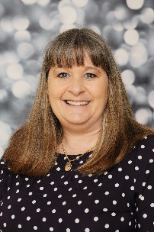

Mrs. Bedford  Headteacher | [Joins Sept 2021]  Deputy Headteacher

TEACHING & LEARNING TEAM
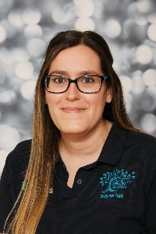 |  |  | 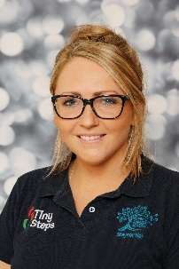 | 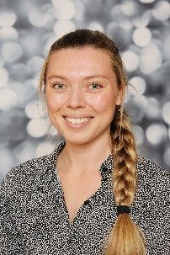
Miss. Powell  Tiny Steps Teacher | Miss. Sullivan  Nursery  Teacher | Miss. Hargreaves  EYFS Lead & Reception Teacher | Miss. Clark  Reception Teacher | Miss. Blythe  Year 1 Teacher

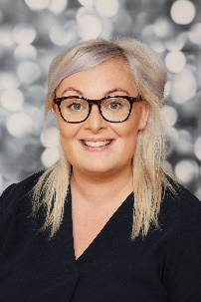 |  | 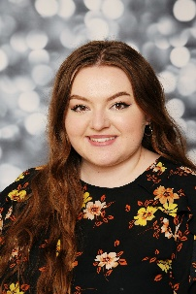 | 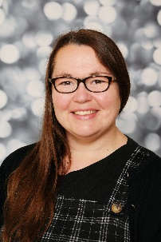
Mrs. Hunter  KS1 Lead &  Year 2 Teacher | Miss. Spark  Year 3 Teacher | Miss. Haigh  Year 4 Teacher | Mrs. Danbury  KS2 Lead &  Year 5 Teacher | Miss. Stewart  Year 6 Teacher

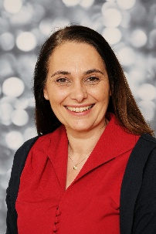 |  | 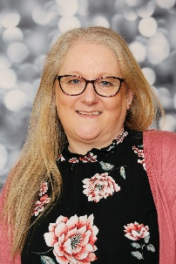
Miss. Steunou  SENDCO | Mr. Jeff  PE Teacher | Mrs. Bell  Personal Development Behaviour & Welfare Lead

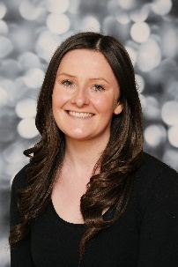 |  | 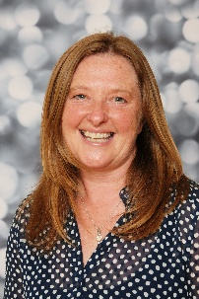 | 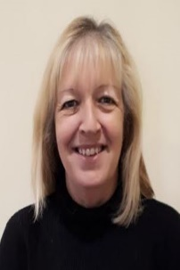
Miss. Aitken  HLTA/Assistant Teacher | Miss. Wylie  HLTA/Assistant Teacher | Miss. Schofield  HLTA/Assistant Teacher/Spanish Teacher | Mrs. Mainds  HLTA/Assistant Teacher | Miss. Mills  Assistant Teacher

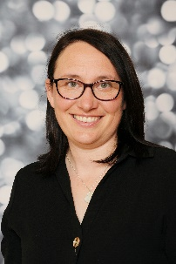 | 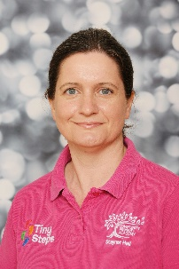 |  | 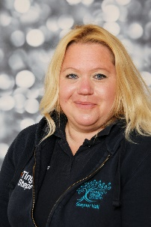 | 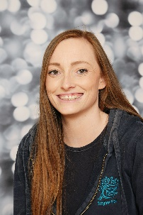
Mrs. Arrand  Assistant Teacher | Mrs. Bugg  Assistant Teacher | Mrs. Coulson  Assistant Teacher | Mrs. Muggleton  Assistant Teacher | Mrs. Elliott  Assistant Teacher

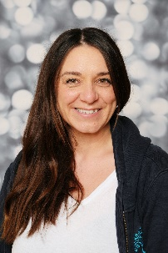 | 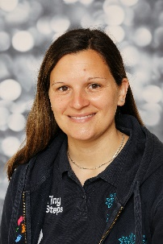 | 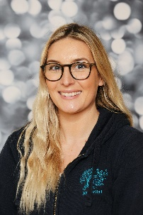 | 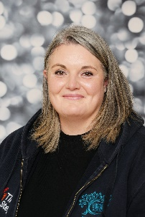 | 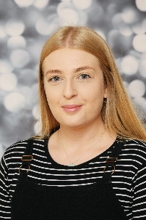
Mrs. Hudson  SEN Assistant Teacher | Mrs. Dilnot  SEN Assistant Teacher | Mrs. Simpson  SEN Assistant Teacher | Mrs. Wilson-Waltham  Assistant Teacher | Miss. Fawcett  Assistant Teacher

ADMIN TEAM
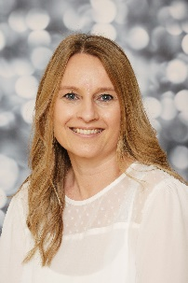 | 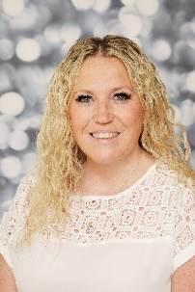 | 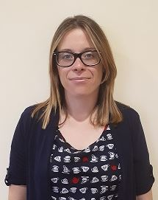
Mrs. Danks  School Business Partner | Mrs. Fickling  Receptionist | Mrs. Roberts  Receptionist

SITE & CLEANING TEAM
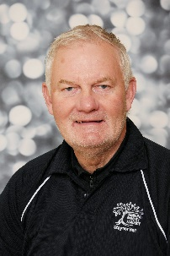 | 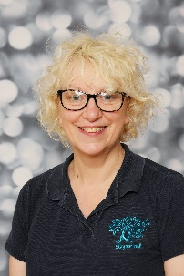 | 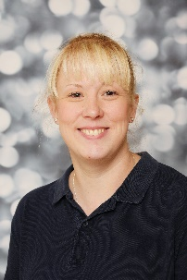 | 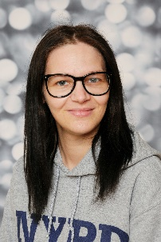 | 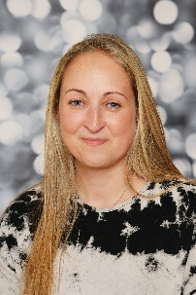
Mr. Gill  Caretaker | Miss. Barlow Caretaker & Cleaner | Mrs. Banton  Evening Cleaner | Mrs. Dunne  Evening Cleaner | Mrs. Suttle  Evening Cleaner

HUTCHISONS CATERING TEAM

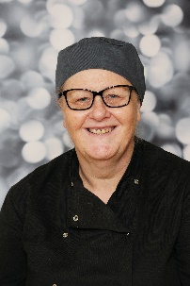 | 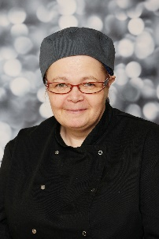
Mrs. Campbell  Catering Manager | Mrs. Brook  Catering Assistant | Mr. Holmes  Catering Assistant

FAMILY DINING ASSISTANTS
 | 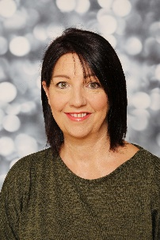
Mrs. Foster | Mrs. Buttery

